PC Assemble

On 1st November 2023, I had attended my first PC Maintenance class which held at Makmal Invoasi (322-02) N28, Level 3A.

In this class, I have learned how to open and install the CPU.

And here are the steps to open the CPU:

1. Open the cover of the computer case.
2. Unplug all cables, except the black one.
3. Open the power supply unit.
4. Unplug the 2GB RAM .
5. Remove the 250GB hard disk.
6. Open the cooling fan.
7. Open the processor.

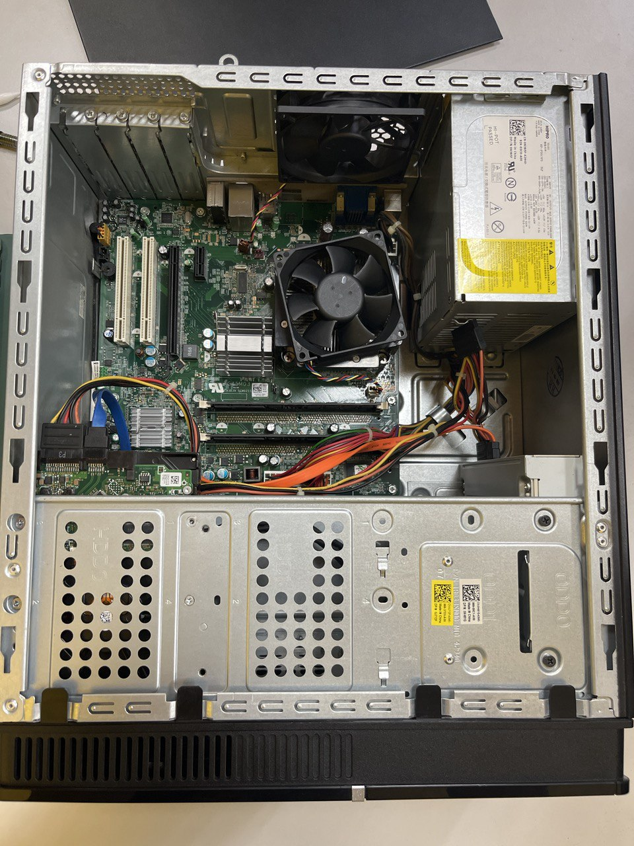

Through this lesson, I get to know more about computer and the class is fun and interesting.